Sentiment Analysis Using Telugu SentiWordNet

In this paper using SentiWordNet author is detecting positive or negative sentences from Telugu sentences, this detection consists of two parts in which using first part we can detect objective or subjective from sentences and if objective words appear in the neutral list of SentiWordNet then that sentence will be consider as Neutral, if words not appear in SentiWordNet Neutral list then sentence words will check inside positive and negative list of SentiWordNet, if sentence words found in positive list then sentence will be consider as positive otherwise negative, if sentences contains words from both positive and negative list then we take ratio of both positive and negative words and if positive ratio higher then sentence will be consider as positive else negative.

Formula for ratio

Positive_ratio = Total_no_postitive_words/total_no_of_words_in_sentence

Negative_ratio = Total_no_negative_words/total_no_of_words_in_sentence

Based on that above score precision, recall and fscore will be calculated

Above sentiment detection will be run inside two algorithms

First algorithm will check objective words of sentences in SentiWordNet Neutral list

Second Algorithm will check subjective words of sentence from positive and negative list of SentiWordNet.

In recent times, sentiment analysis in low resourced languages and regional languages has become emerging areas in natural language processing. Researchers have shown greater interest towards analyzing sentiment in Indian languages such as Hindi, Telugu, Tamil, Bengali, Malayalam, etc. In best of our knowledge, microscopic work has been reported till date towards Indian languages due to lack of annotated data set. In this paper, we proposed a two-phase sentiment analysis for Telugu news sentences using Telugu SentiWordNet. Initially, it identifies subjectivity classification where sentences are classified as subjective or objective. Objective sentences are treated as neutral sentiment as they don’t carry any sentiment value. Next, Sentiment Classification has been done where the subjective sentences are further classified into positive and negative sentences. With the existing Telugu SentiWordNet, our proposed system attains an accuracy of 74% and 81% for subjectivity and sentiment classification respectively.

We downloaded BOOK REVIEWS sentences from internet to detect sentiment and downloaded SentiWordNet list also.

BOOK REVIEWS sentences store inside ‘Book_Reviews_Sentences’ folder

SentiWordNet list saved inside ‘Telugu_SentiWordNet’ folder

Screen shots

To run project double click on ‘run.bat’ file to get below screen

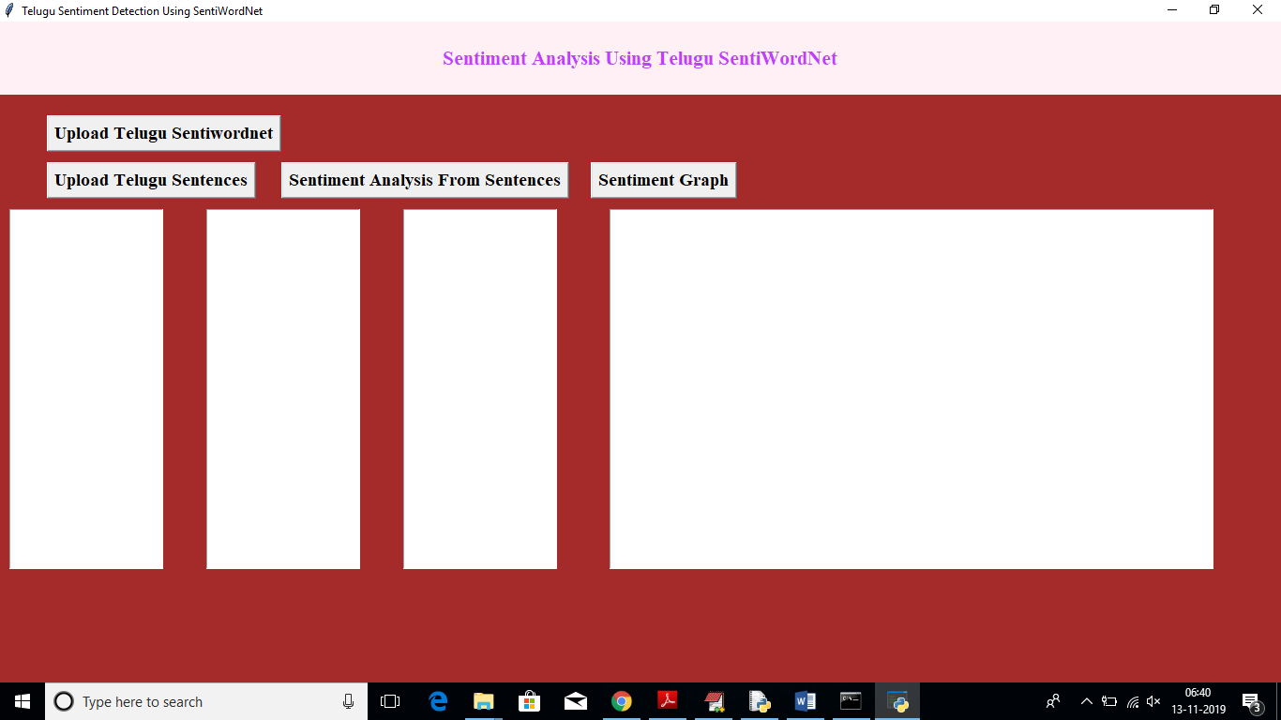

In above screen click on ‘Upload Telugu SentiWordNet’ button to load sentiment words list such as NEUTRAL, POSTIVE, NEGATIVE to application from SentiWordNet database

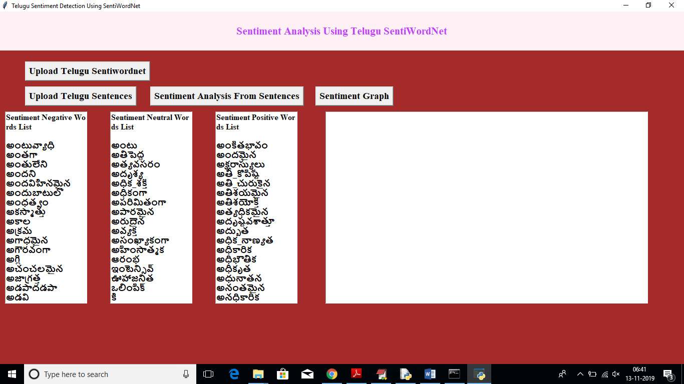

In above screen all three list read from SentiWordNet and display inside different text areas. To view entire list scroll down text area. Now click on ‘Upload Telugu Sentences’ button to upload sentences file

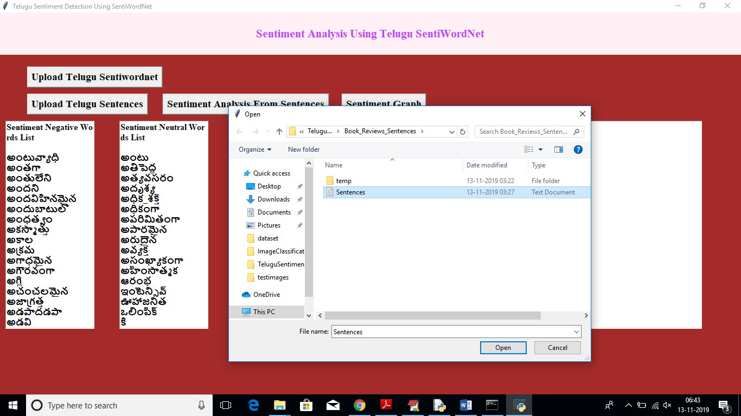

In above screen uploading sentences file, after upload will get below screen

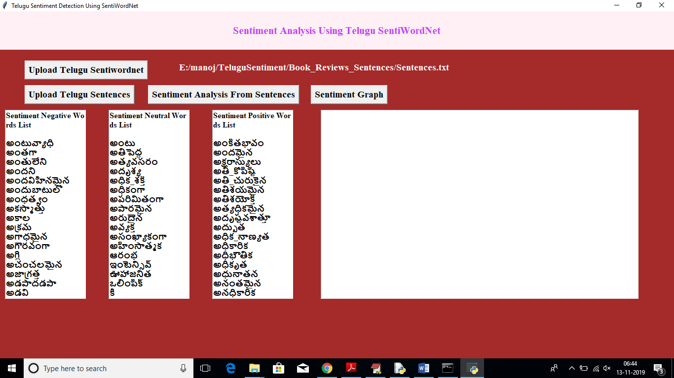

Now click on ‘Sentiment Analysis From Sentences’ button to detect sentiment from each sentence

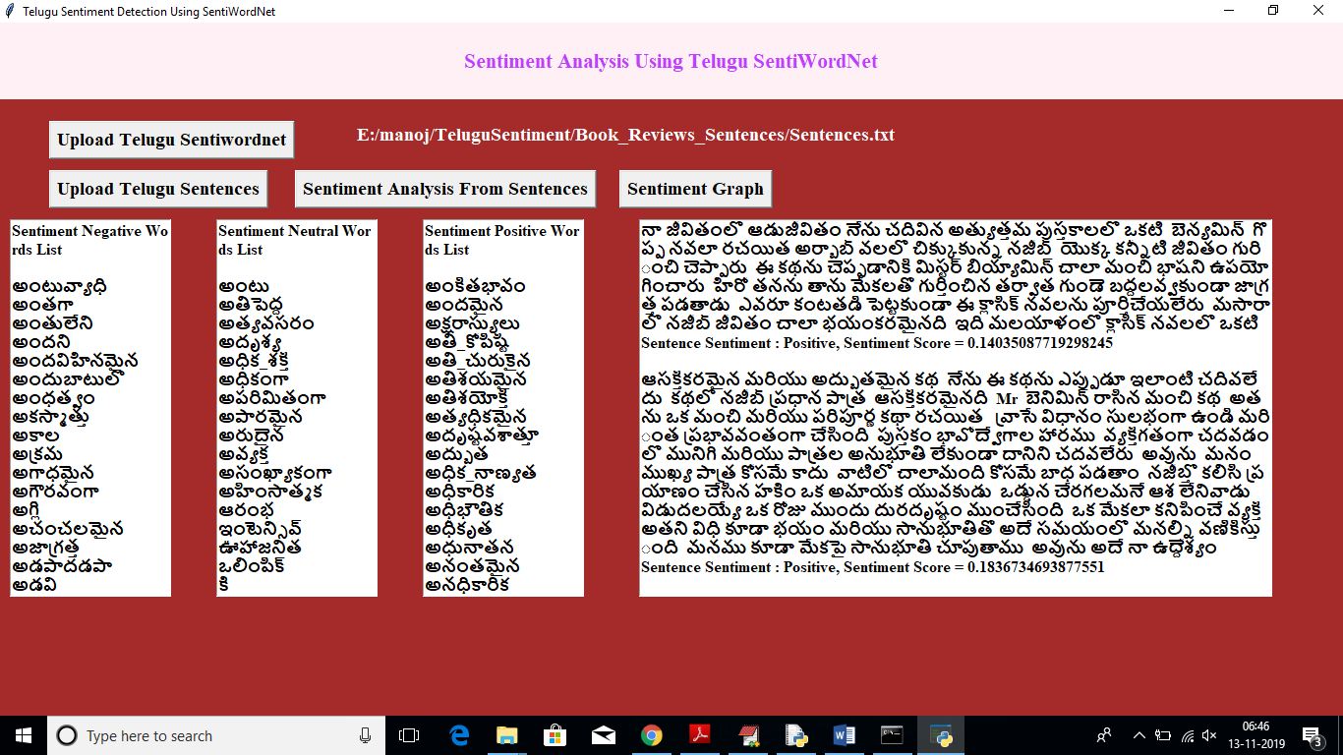

In above screen in fourth textarea we can see each sentence and below that sentence we can see whether sentences contains positive or negative sentence and beside we can see score also. Scroll down textarea to view all sentences and its sentiment

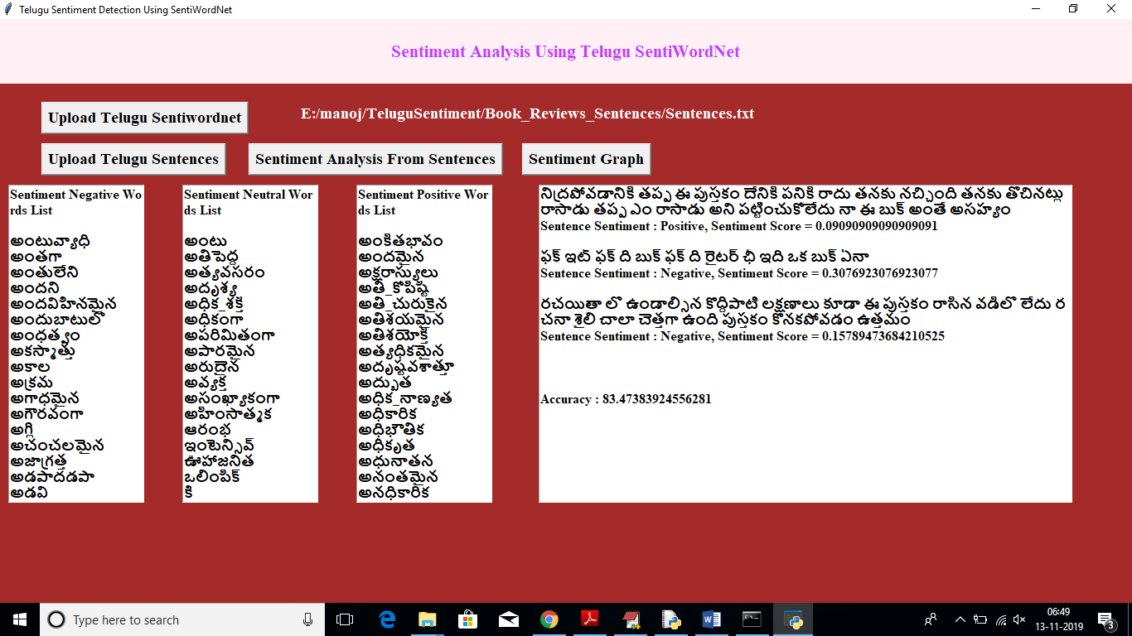

In above screen we got accuracy value also, now click on ‘Sentiment Graph’ button to see total sentences, positive and negative sentences count in graph

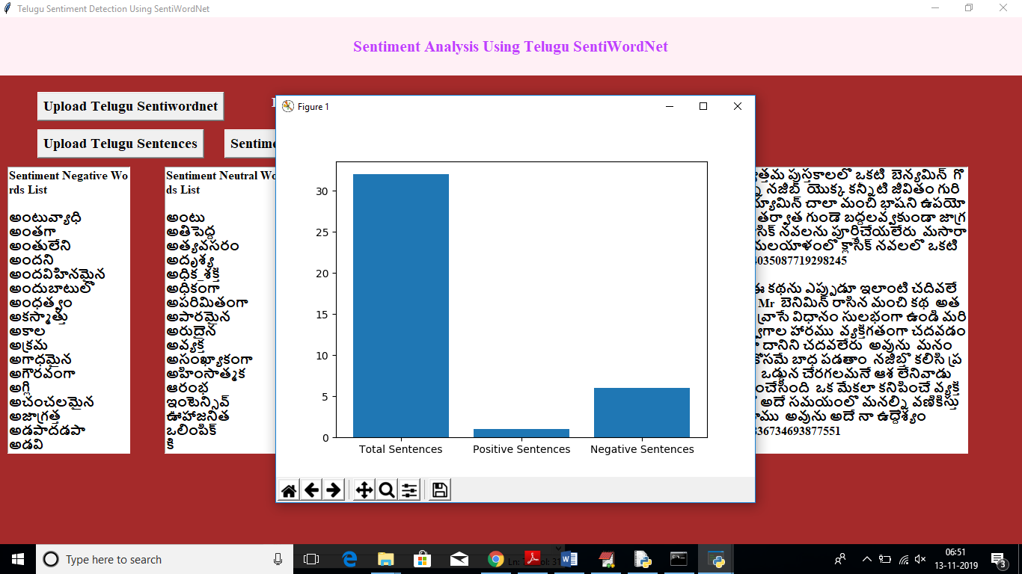

In above graph x-axis represents sentence type as total, positive and negative and y-axis represents count